A free market bailout alternative?

Corresponding author:
Philipp Bagus
Universidad Rey Juan Carlos
Department of Applied Economics I
Paseo Artilleros s/n.
Madrid, 28032, Spain
philipp.bagus@urjc.es
Tel: 0034 657513505
Fax: 0034914887671

Juan Ramón Rallo Julián
Universidad Rey Juan Carlos
Department of Applied Economics I
Paseo Artilleros s/n.
Madrid, 28032, Spain
juanrallo@gmail.com
Tel: 0034 696611567
Fax: 0034914887671

Miguel Ángel Alonso Neira
Universidad Rey Juan Carlos
Department of Applied Economics I
Paseo Artilleros s/n.
Madrid, 28032, Spain
Tel: 914888029
Fax: 0034914887671

Abstract:
It has been more than three years since the collapse of the investment bank Lehman Brothers and the beginning of the Troubled Asset Relief Program (TARP). Most recently, the sovereign debt crisis in Europe has led to the bailout of the governments of Ireland, Portugal and Greece. A main reason behind these bailouts is to support European banks loaded with government bonds on their balance sheet. In this article we analyze the detrimental consequences of the public bailout in 2008 and argue that a free market alternative existed. The alternative of a private bailout outlined in this article, consisting of the conversion of liabilities into equity and a private capital increase, largely avoids the problems of a public bailout. Similarly, a public bailout of governments of the Eurozone to sustain banks may be detrimental.
Key words: financial crises, credit expansion, bailout, crowding-out, moral hazard.
JEL Classification: E32, E52, E65, G01, G33, G38, H81, K 10, K 20

A free market bailout alternative

It has been more than three years since the collapse of the investment bank Lehman Brothers and the beginning of the Troubled Asset Relief Program (TARP) by the Bush Administration. Similar plans to support and bailout the banking system have been enacted worldwide. Problems continue because many banks are potentially insolvent especially in the wake of the sovereign debt crisis in Europe. In the eyes of the prevailing opinion, the recapitalization of insolvent debtors with tax payers´money becomes ever more an urgent necessity. Recent examples are the bailouts of the governments of Greece, Portugal and Ireland. The Irish government´s problems result primarily from a bailout of its banking system. In September 2011 the International Monetary Fund estimated potential losses for banks due to the sovereign debt crisis at €300bn. and urged a second recapitalization of European banks. In this article we want to analyze if the multi-billion dollar plans of the first round of recapitalization in 2008 in the U.S. were the only alternative to prevent a financial apocalypse or if other possibilities more in line with the free market existed. The experience of the United States after the collapse of Lehman Brothers serves to provide an alternative plan applicable to the European sovereign debt crisis.

Causes
In order to address this question we should first explain the origins and history of the crisis. Without an understanding of the causes of the financial crisis, we neither know which kind of problems financial institutions face nor which are the options to alleviate their problems most efficiently. As has already been analyzed by the commonly named Austrian School, our current financial system provokes recurrent economic cycles of boom and bust.
Financial intermediaries – i.e. financial institutions like banks, monetary funds, conduits, financial departments of corporations and assurances – have changed their business model in the 20th century. Traditionally, commercial banks attracted and created deposits by discounting bills of exchange while investment banks issued long-term bonds in order to invest in different long-term projects such as mortgages and commercial and consumer credits. This behavior had been more in line with the golden rule of banking that dates back to Otto Hübner (1853). The rule demands that banks match the maturities of their assets and obligations. With minor deviations, banks adhered to this rule until the beginning of the 20th century, especially in Great Britain. Unfortunately, commercial banks increasingly began to finance long-term projects under the assumption that their balance sheet remained liquid as long as their assets were shiftable (Moulton, 1918). In fact, during the last decades the explicit objective of all kind of banks has been to “transform maturities” or “mismatch maturities”. Deposit creation by lending long term to investors is one instance of such a transformation of maturities. The proclaimed aim of maturity transformation is to borrow short term at low interest rates and invest in long-term assets with a high yield.
While the arbitrage of the bid/offer spread between buyers and sellers of the same good offers important coordination benefits, the arbitrage of interest rates of different terms discoordinates the plans of savers and investors, when the volume of credit becomes larger than the volume of real savings. The inherent liquidity risk of this arbitrage is reduced in the short run by government interventions such as implicit bailout guarantees and central banking. Yet, this just allows distortions in the economy to accumulate.
In essence, savings imply a period of abstention from consumption. During this period factors of production are not used to satisfy directly consumer needs. Thus, savers themselves or other investors may dedicate these resources to the production of capital goods that increase income or the supply of consumer goods in the future. In this inter-temporal coordination of the decisions of economic agents, it is crucial that the new investments yield consumer goods at the very moment when the savers want to stop being savers and start consuming.
When inter-temporal coordination fails, the new capital goods industries may lose their source of finance and the costs of factors of production increase. Capital and factors are bid up by consumer goods industries that need to expand production at a faster rate to satisfy consumers’ needs. Finally, industries have to close, liquidate or reorganize their projects in order to adapt to consumer needs: their cash-flow will be lower than initially expected and they will be unable to continue servicing their cost of capital (specially their debt).
The process of inter-temporal discoordination and maturity mismatching is strictly limited in a free market. If a bank systematically borrows short and invests long it will get a substantial negative working capital and, consequently, problems in refinancing its debt. When depositors and short-term creditors want to use their funds and the rest of the banks are not willing to grant interbank credit, the illiquid bank must suspend payments and restructure its assets to make them fit their liabilities better.
This limitation to maturity mismatching is resolved in our modern societies by central banks (Alonso et al., forthcoming; Bagus 2010). Central banks are monopolist issuers of legal tender money and lenders of last resorts to the banking system. As such, these semi-public or entirely public institutions have the capacity to renew permanently the short-term debt of private banks via open market operations or the discount window. Thus, illiquid banks can continue to arbitrage interest rates and distort inter-temporally the plans of economic agents. However, this process also has a limit. The limit is reached when the structure of production and the relative prices of distinct assets in the economy become so distorted that not even a decisive credit expansion by the central bank at favorable terms can convince investors to assume new debts and decrease their liquidity further.
At this point banks are highly leveraged holding short-term debts and assets of disproportionately high or bubble values. Moreover, interest rates for new loans and prices of factors of production increase as there is a lack of savings. Capital and factors are used in capital goods industries and need to be employed in consumer goods industries. The crisis breaks out.
The crisis is not a period of penury that should be evaded at all costs, but rather a stage in which consumers, savers and investors readjust their plans in order to return to a coordinated production of wealth. Since banks have been the motors of fiduciary credit expansion, the crisis will usually affect them with special intensity, even putting them on the verge of bankruptcy. Bank bankruptcies are problematic processes which, as has been argued, may lead to a secondary contraction (Friedman and Schwartz 1971). The three traditional ways of avoiding this painful process have been more central bank inflation, a general deflation and liquidation, or a public bailout. However, there is a fourth alternative that in many cases will be preferable: a private recapitalization.
Before we turn to this alternative, we will look upon the dynamics leading to the current crisis. The starting point of the current boom and bust cycle coincides with the exaggerated interest rate reductions conducted by Alan Greenspan during 2001 and 2002 in order to prevent the bursting of the dot-com bubble and alleviate the effects of 9/11 and an impending recession. In a coordinated manner, the Federal Reserve and the rest of the world’s central banks held interest rates at historically low levels (at 1% during one year in the case of the Fed and at 2% during two years in the case of the European Central Bank). This triggered a credit expansion in all sectors of the economy.
The credit expansion was not only conducted by commercial banks but also by what was later called the shadow banking system. The development of the shadow banking system was mainly due to the Basel II regulation (Jablecki and Machaj, 2009). The characteristic of this part of the financial sector was that it acted like commercial banks (borrowing short and investing long) without being submitted to the regulation of central banks in regard to liquidity and equity ratios. This group consists of insurers, special purpose vehicles (SPV), government agencies (especially real estate financers), and investment banks among others.
Through different mechanisms and financial instruments the shadow banking sector attracted short-term funds in the money market and invested them in long-term assets such as asset backed securities (ABS). The most important and largest part of ABS constituted mortgage backed securities (MBS). The maturity mismatching generated a continuous need to refinance or roll-over the short-term liabilities of the shadow banking system. This was possible due to the enormous credit expansion that central banks induced in the rest of the economy. The low interest rates induced security buyers to look for sources of high returns. The investment bankers supplied them, supposedly, via new tranched securities. The rating agencies cooperated (White, 2009). In this way a cumulative process ensued: the shadow banking sector used the short-term funds provided by commercial banks, the money market funds or cash holdings of corporations in order to purchase securitized assets of banks, which again fostered the banks’ credit expansion at favorable terms.
As the artificially low interest rates fell lower and lower, more and more long-term entrepreneurial projects were started. However, these projects were not profitable as they were not in line with the plans of savers. Savers did not renounce using the capital and factors of production that these new projects required in the consumer goods industries. Projects did not produce the quantity and quality of consumer goods at the moment and price at which savers demanded them. Loans to these projects lengthened the balance sheets of both the traditional banks as well as the shadow banking system via the securitization of credits designed by the former.
Finally, the insufficient profitability of these projects became apparent and there was insufficient demand to sell all newly produced and securitized credits. Financial costs rose as interest rates increased. Commodity prices soared because their supply had not been increased sufficiently due to the deviation of credits into the sectors in which the bubble activities occurred. As a consequence, debtors defaulted on their obligations and financial institutions had to cope not only with an enormous maturity mismatching and the need to refinance their short-term obligations, but also with an insufficient amount of equity that could have helped them to cushion the losses of their excessive leveraging. Trust in counterparties evaporated and credit markets collapsed (Yandle 2010).
In such a vicious circle two problems tend to reinforce each other: the difficulties in refinancing the short-term debts oblige mismatching institutions to liquidate long-term assets at prices that are inferior to those registered on the balance sheet. This deteriorates the capital of the company even more. At the same time the increase in default risk complicated the access to credit markets.
A simple view upon the last balance sheet of the main financial entities in the United States before September 2008 (figure 1) will help us to understand their problems. On the one hand, their equity did not even compensate for a 5% depreciation of their assets, i.e, there was an over-leverage derived from the cheap credit policies of the preceding years.
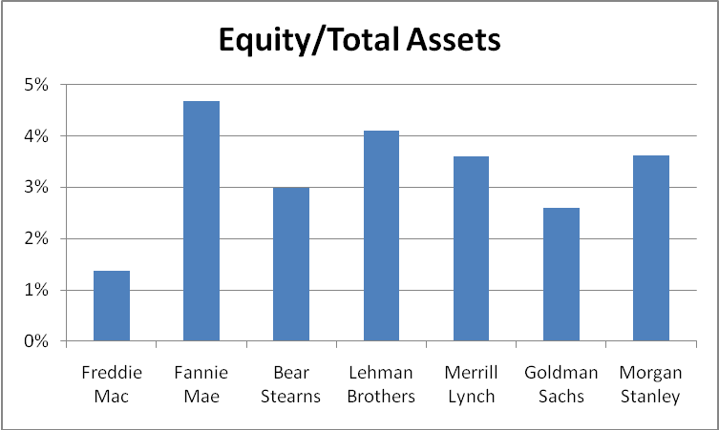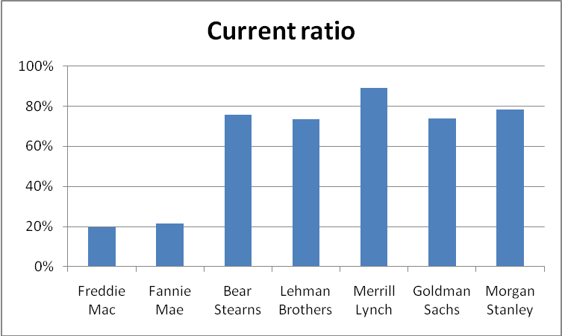

Figure 1: Equity ratios selected financial institutions Figure 2: Current ratio selected financial institutions
Source: Quarterly Financial Statements (2008, own calculations)

On the other hand, the current ratio of these entities was in all cases below 85% (figure 2). In other words, in the best case 15% of short-term debts was not covered by current assets (defined as cash plus short-term claims and not including long-term securities such as trading assets which banks were unable to liquidate without huge discounts in their price) and had to be refinanced in the markets.

The bailout of the investment bank Bear Stearns in March of 2008 showed paradigmatically how both problems tend to reinforce each other: the assets of Bear Stearns served as collateral for its repurchase agreements that refinanced its short-term debts. These assets depreciated due to their exposure to delinquent MBS. The important increase in counterparty risk had a negative effect on the willingness of its creditors to renew Bear Stearns’ short-term debt. This in turn led to the precipitated liquidation of its assets and an imminent bankruptcy that was only prevented by a coordinated bailout on the part of the Federal Reserve and JP Morgan.
In September Lehman Brothers, after experiencing a process analogous to that of Bear Stearns, was not so lucky. Federal authorities changed their previous bailout criterion for unclear reasons and let the bank fail. From that moment on uncertainty skyrocketed in financial markets and the door was open for a secondary contraction.

Secondary contraction and necessary liquidation
We have already seen that crises are not periods that should be prevented but rather stages of catharsis and the healthy purge of malinvestments. They bring the structure of production in line with inter-temporal consumer preferences by liquidating unsustainable (bubble) investments. During a crisis there is a redistribution of assets and factors of production, the relative prices in the economy adjust, savings tend to increase and the indebtedness of households and companies is reduced. In general, the liquidity of the economic agents increases setting the basis for subsequent and sustainable growth.
The crisis is a healthy period. Therefore, it is not convenient to consolidate productive structures that arose from credit expansion and do not coordinate inter-temporarily the behavior of economic agents keeping unprofitable businesses afloat. Moreover, sooner or later these structures must be liquidated as they are not in line with consumer wishes. The liquidation of these productive structures reduces the prices of certain assets. These assets may be reconverted and used in a profitable way in other areas of the economy. Furthermore, factors of productions will be liberated and may be used to satisfy the real needs of consumers.

While the liquidation of past investment errors is inevitable for the beginning of the recovery, a secondary contraction or depression is not necessary. In a secondary contraction not only are malinvestments liquidated but also investments that are sustainable with proper financing. Banks’ liabilities – such as demand deposits – are no longer used as a means of payment in the rest of the economy, thus a substantial price deflation is needed to perform all transactions in cash. There are many investments that satisfy consumer wishes but the destruction of “bank money” forces them into bankruptcy. In a secondary contraction loans are not renewed which leads to a liquidity crisis where assets are liquidated and loans defaulted. This reinforces the liquidity crisis leading to a financial panic.
An early liquidation would not be a problem for the economy in general in case prices were not too rigid due to government interventions. The liquidation does not create new malinvestments and therefore does not generate another artificial boom (Rothbard 2001, p. 865). It mainly leads to a redistribution that may be severe. The assets are sold at low prices and may be used for similar or totally different sustainable business structures.
After the failure of Lehman Brothers, the world financial system was at the edge of a secondary contraction. The secondary contraction was fought against by two main instruments: central banks refinanced the short-term debts of banks and governments recapitalized financial entities through different bailout plans.
In the last trimester of 2008 central banks substituted the interbank market. They lent short-term funds to banks that needed them when the interbank market collapsed. At the same time they received (excess) reserves from the banks that withdrew from the interbank market bank. Thus, central banks started to play the role of the interbank market by redistributing short-term funds between banks with excesses and those with deficits.
The second measure, the bailout plans for the banking system, were more extraordinary and on a hitherto unseen scale. Different governments infused funds into financial entities to prop up their capital. These plans removed part of the uncertainty about the future viability of banks and favored, to some extent, a normalization of credit markets. The widely feared secondary contraction was prevented or at least postponed.
While the pursued aim of preventing a secondary contraction was achieved, the bailout plans entailed some costs that may prolong the crisis longer than would have been necessary:
- Indiscriminate bailout: it is not necessary that the liquidation of malinvestments causes a general liquidation and redistribution of capital. But at the same time the intention to prevent a general redistribution of capital could prevent the necessary liquidation of malinvestments. The recapitalization plans of governments bailed out almost indiscriminately all entities under the premise that no one should be allowed to fail. Not only bankruptcy caused by illiquidity was prevented but also bankruptcy caused by insolvency. The latter is more problematic as it implies the consolidation of business models that should have disappeared. In this case a political objective was confused with an economic one. As a consequence many assets of bad quality still remain on the balance sheets of banks instead of being redirected into other sectors of the economy.
- Crowding out of private savings: the bailout plans were financed, to a large extent, by the emission of public debts which were sold in the market at especially delicate moments. Public debt competed with private debt in moments of extraordinary tensions of credit. A great number of savers invested their money into government obligations. As a result, credit markets dried up even more. The scarcity of funds complicated the financing of companies that tried to finance their stock via commercial paper as money market funds stopped buying them. Moreover, problems for financial companies that securitized their consumer credits were aggravated. The problems of financial companies restricted even more the available funds for the purchase of durable consumer goods such as houses and cars. To the extent that the public bailout plans did not pretend to temporally help banks with liquidity problems but to solve any solvency troubles, the provided funds were higher than necessary and implied not only a waste of scarce resources but also a crowding out of private credits.
- Moral hazard: the indiscriminate bailout of the creditors of the financial system exacerbates an already existing moral hazard problem which will be hard to contain in the future. Particular entities are considered too big to fail. There is an implicit guarantee by the government for all types of investments with these entities. As a consequence, the risk premium that these entities have to pay on their debts will be substantially inferior to the risk that they are assuming. In the long run, as has been illustrated by the case of Freddie Mac and Fannie Mae, government guarantees lead to an excessive leverage in too risky projects and, finally, to the necessity of injections of public capital. By this, the risk and potential losses are shifted on to society while the projects had served to provide extraordinary profits for a few individuals.
- Regulation of decision making: the majority of bailout plans imposed concomitantly with the injections of capital a series of regulations on decision making of these entities. These regulations consisted mainly in the payment of preferred dividends to the Treasury and salary and bonus caps for managers. These government interventions in the life of companies complicate the managing of them and even endanger their survival. For instance, Richard Kovacevich, chief executive officer of Wells Fargo thinks that the preferred dividend that his entity had to pay to the Treasury limited its capacity to remunerate its shareholders (Levy, 2009). This in turn, limited the banks’ capacity to attract capital on the market.
- The problem of exit strategies: some bailouts have converted governments into major shareholders of financial institutions. As shareholders, governments may influence the decisions of the management in regard to executive selection, salaries, strategies and credit policies. This influence may be used to pursue political goals. For instance, credits might be granted to political allies or finance industries connected with the government. Fortunately, most governments want to exit their engagements. However, there is no consensus about the way to exit (Thune, 2009). An early exit might destabilize the financial system again. A late exit may distort management decisions in favor of governments. Moreover, the price at which the exit occurs and the stocks are sold may be too low leading to windfall profits for the buyers or too high leading to losses for investors.
- Regime uncertainty: related to the problem of exit strategies is regime uncertainty. Robert Higgs (1997, 2010) defines “regime uncertainty” as a situation where it is very uncertain what the economic order will look like in the future, especially how property rights will be treated by the government. Thus, regime uncertainty discourages long-term savings and investments. The bailouts of financial institutions turned governments into major shareholders of the financial system. The participation of governments in management decisions and the problem of exit contributed to regime uncertainty (Taylor, 2009). It is not clear how the semi-nationalized financial system and its shareholders’ property rights will be treated in the future and what kind of government guarantees will materialize. The profitability of investments into the financial sector depends, to a large extent, on future government actions. This regime uncertainty makes an equity increase via private capital more difficult and discourages long-term savings which are essential for a recovery of the economy. Lastly, nothing basic is being done to alter the system. Once the band-aids are applied, the system goes on to its next catastrophe.

A free market alternative
After reviewing the adverse consequences of the bailout we are faced with the question of whether an alternative existed that is more in line with the principles of a free market and that would also have prevented a secondary contraction. Is there a free market alternative that would have achieved better results than the public bailout in the sense that it would not only have prevented a secondary contraction but also prevented one or all of the aforementioned six problems?
For a free market alternative to be viable it is essential that governments rule out and eliminate any possibility of a public bailout of financial entities. Otherwise the expectation of a bailout will induce creditors, shareholders and managers of the company to abstain from the free market alternative and try to shift its costs onto the shoulders of society. Moreover, governments could have promoted these alternatives by increasing their expected profitability after taxes via significant spending and tax reductions. Through a reduction of the size of government, more resources would have been available in the private sector that could have financed the private bailout.
Assuming that the barriers against a free market alternative such as public assistance for banks, high taxes, and government induced uncertainty are eliminated a private initiative could prevent the so-called anticipated secondary contraction through two mechanisms: the conversion of liabilities into equity and an equity increase via capital markets.
The first mechanism is typical for bankruptcy proceedings and consists of converting debt into equity. In this way the entity is recapitalized automatically which allows it to function until its long-term assets mature. Creditors obtain a portion of the property of the company.
This solution coincides, more or less, with the proposal of Kevin Dowd (2010) and Nassem Taleb and Mark Spitznagel (2009) of converting insolvency from a discrete into a continuous variable. Thus, a company can go from solvency to insolvency and vice versa without necessarily forcing the automatic liquidation of the company. In this manner, Taleb and Spitznagel (2009) argue: “The only solution is to transform debt into equity across all sectors, in an organised and systematic way”. A similar proposal comes from Paul Callelo and Ervin Wilson (2010) who call the conversion of creditors into shareholders a “bail-in”. They argue for a bankruptcy code that enables such a conversion in an efficient way.
It should be kept in mind that bankruptcy proceedings have been introduced in order to protect creditors. When the assets of the company are liquidated, their value keeps falling and it gets more difficult to recover the initial investment. Thus, the avoidance of liquidation may be beneficial for both creditors and shareholders. In fact, Callelo and Wilson (2010) estimate for the case of Lehman Brothers:
“According to market estimates at the time, Lehman’s balance-sheet was under pressure from perhaps $25 billion of unrealised losses on illiquid assets. But bankruptcy expanded that shortfall to roughly $150 billion of shareholder and creditor losses, based on recent market prices. In effect, the company’s bankruptcy acted as a loss amplifier, multiplying the scale of the problem by a factor of six.”
In a free market alternative, creditors could decide if they believed in the viability of the business model and consequently converted themselves into shareholders or if they, on the contrary, preferred proceeding to liquidate the company. In any case, instead of injecting public capital with the objective to prevent a secondary contraction it is preferable that the government forces creditors to assume part of the losses necessary to recapitalize the company. Creditors should assume the losses, because they voluntarily invested in the company. In a public bailout the losses are externalized to the rest of society.
If we take as reference the capital injections made by TARP in order to prevent a secondary contraction (figure 3), the quantity of liabilities that had been necessary to be converted into equity was in no case higher than 9% of total liabilities of the entities that were bailed out. Of course, we should consider that the losses should be apportioned in function to the maturity of the debt. A 30-year bond is more similar to equity than a demand deposit. Hence, we may regard short-term creditors and depositors who want to safeguard their money or get a yield out of short-term funds as a different category than long-term creditors who dedicate their savings to long-term projects. Even with this distinction the conversion of long-term debt into equity was viable and not a bad option, especially if we take into account that the creditors of Lehman Brothers lost 91% of their capital.
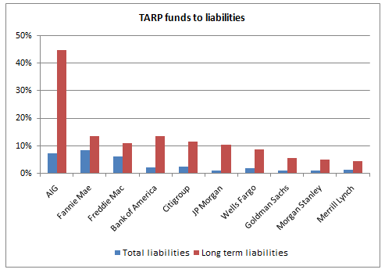
Figure 3: TARP funds to liabilities
Source: Quarterly Financial Statements (2008, own calculations)
The conversion of liabilities into equity solves a great part of the problems that entails a public bailout. To the extent that it is voluntary, it is creditors themselves that have the option to analyze and judge if the business is viable in the long run and if they are willing to transform a part of their credits into equity order to become owners of the entrepreneurial project. Thus, the bailout is not indiscriminate and the assets tend to be invested in those projects that have the highest expected yield. In other words, the adverse effects of crowding-out and diverting private capital into unprofitable investments are also prevented.
At the same time, the conversion of liabilities into equity does not generate moral hazard problems either as shareholders and creditors alike bear all the costs of the bailout. Furthermore, the discretionary regulations involved in public bailouts disappear in the free market alternative: it is still the owners who, taking into account the particular circumstances of every company, choose if they want to change the board, suspend dividends or eliminate bonuses of top managers. This also implies that there is no political exit strategy problem. Governments do not have to decide when and how to exit their engagements. There is no political influence upon management decisions via public ownership. Shareholders with their private and unique knowledge may decide if and when they sell their shares. The exit problem is privatized. Lastly, regime uncertainty is decreased. There is no massive government intervention into the financial sector and private property rights of shareholders are less uncertain.

The second mechanism of a free market bailout is an equity increase via capital markets. This mechanism boosts capital, helps to refinance short-term debts and prevents the suspensions of payments. When we observe 30-year interest rates of companies rated Baa by Moody’s (the last rating considered investment grade) we see that they followed the 30-year interest rate of United State debts rather closely (figure 4), except for a short period following the collapse of Lehman Brothers in September 2008. Apart from this short period in which the increase of uncertainty in the end was only manifested by a premium of 250 basis points, the interest rates paid by companies rated Baa changed in a similar way and rhythm as the rates of public debt.

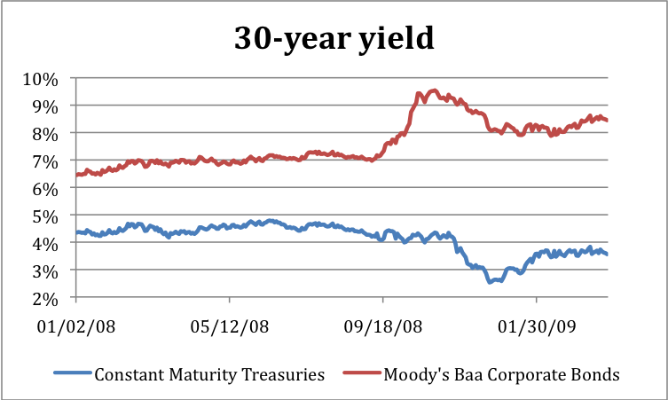

Figure 4: 30-year yield

Source: Federal Reserve St. Louis (2009)

The data indicates that it is not true that financial markets were closed to private companies and that governments were the only entities capable to indebt themselves. In fact, the maximum risk premium was 600 basis points, which would not have made a placement impossible; only for the least profitable projects that, consequently, should be liquidated.
It is true that banks did not need to attract more debts but more equity. Yet, 30-year debt may serve as a good approximation for the annual yield that a capital increase must offer to be successful. Even though the cost of equity is higher than the cost of debt (due to the higher risk and the variation in the remuneration), 30-year debt approximates closely an investment in variable rent. Furthermore, we should not forget that almost all banks had a credit rating in the third trimester of 2008 that was substantially higher than Baa.
It is also true that many banks and monetary funds suffered transitional liquidity problems. These liquidity problems supposedly could only be solved through guarantees of their financial operations by the distinct governments. However, the data does not show the impossibility of refinancing. In fact, interest rates of financial paper increased barely 100 basis points after the failure of Lehman Brothers. Thus, rates were still below the level of the beginning of 2008.
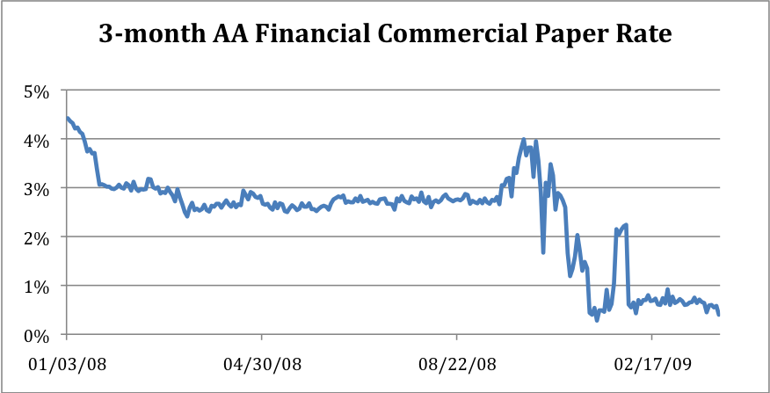

Figure 5: 3-month AA financial commercial paper rate

Source: Federal Reserve Saint Louis
Therefore, it can be hardly argued that the financial system would not have been able to increase its capital to refinance its short-term debt during the panic provoked by the failure of Lehman Brothers. The private refinancing of short-term debts has some advantages in comparison with the public injections of capital and the government guarantees for bank debts: it would not have been indiscriminate, it would not have generated moral hazard problems, it would not have distorted the decision making process within the companies, it would not have created a political exit problem and it would not have contributed to regime uncertainty. There would only have been a certain crowding out effect as private savings were attracted, but just because it was the preferred investment by private savers. Yet, this crowding out effect would have been much lower than the crowding out induced by the government because not all investments would have been sustainable and many of them would have failed.

Conclusion
During the weeks following the failure of Lehman Brothers the great majority of politicians and economists maintained that the public recapitalization of the financial system was the only viable way to solve solvency and liquidity problems. They created an apparent consensus that later served to justify intense interventionist activities. Despite this consensus there existed private alternatives that are more consistent with the free market and more adequate than the public one.
The bailouts conducted by the government did divert the savings of tax payers into the private investments of certain economic agents. They also prevented the liquidation of entrepreneurial projects of low profitability and the liberation and reallocation of factors of production. Thus, the economy tends to stagnate with a structure of production that is outdated and does not satisfy the most urgent needs of consumers and savers. The recovery as well as the creation of wealth is delayed.
Moreover, the public bailouts introduced other distortions into the normal evolution of free markets such as the inferences with internal decision processes of the recapitalized companies through regulation of their activities. The bailouts also created the expectation of new public bailouts of companies considered too big to fail in the future. In other words, private companies are severely restricted in their capacity to adapt themselves in a changing market environment and at the same time investors are induced to ask for artificially low risk premiums assuming a future public bailout. Furthermore, a public exit problem was created and regime uncertainty was increased due to the strong public ownership in the financial sector. Property rights and the profitability of investments, especially in the financial sector, started to depend heavily on future government actions.
The alternative of a private bailout outlined in this article consisting of the conversion of liabilities into equity and a private capital increase avoids, to a large extent, these problems.
In this alternative any investor may judge in situ the specific profitability of their investments thanks to the private and disperse information the investor manages. As a consequence, the consumption of capital and the resulting crowding out may be minimized. The private investor may also exit the investment whenever they see fit. Furthermore, neither moral hazard is created nor is the decision making process distorted because the risk and the decision making are fully assumed by every company. The rules of the market and property rights are respected reducing regime uncertainty.
In the case of the European sovereign debt crisis, the European Commission and the European Central Bank argue that losses for the banking sector have to be prevented at all costs. They fear a financial catastrophe if governments are not bailed out due to losses for banks. The result of this recommendation maybe substantial institutional changes in the Eurozone such as the introduction of a de facto transfer union, where payments flow from richer to poorer states (see Heinen, 2011). Yet, the private bailout alternative can be applied to the case of the European sovereign debt crisis. A private bailout as outlined in this article would lead to a sounder European banking system and prevent substantial moral hazard and costs for tax payers.

With these unquestionable advantages for tax payers and the economy, one may wonder why so few voices advocated such an alternative. Yet, at this point we enter the murky waters of politics and the exploitation of the crisis by governments and leave the field of a rigorous analysis of reality and possible economic policies.

References
Adrian, Tobias and Hyun Song Shin. 2008. “Financial Intermediaries, Financial Stability and Monetary Policy.” Paper presented at Federal Reserve Bank of Kansas City Symposium at Jackson Hole August 21-23. Available at: http://www.kc.frb.org/publicat/sympos/2008/Shin.08.06.08.pdf.
Alonso, Miguel A., Philipp Bagus and Juan R. Rallo. Forthcoming. “The First Global Financial Crisis of the 21st Century: Origins and Proposals of Reform. An Austrian Approach.” Journal of Interdisciplinary Economics and Business Law.
Bagus, Philipp. 2008. “Monetary Policy as Bad Medicine: The Volatile Relationship between Business Cycles and Asset Prices.” The Review of Austrian Economics 21(4): 283-300.
Bagus, Philipp. 2010. “Austrian Business Cycle Theory: Are 100 Percent Reserves Sufficient to Prevent a Business Cycle?” Libertarian Papers, 2(2).
Boettke, Peter. 2008. “Regime Uncertainty”. The Austrian Economist, October 6. Available at: http://austrianeconomists.typepad.com/weblog/2008/10/regime-uncertai.html
Brunnermeier, Markus. 2009. “Deciphering the Liquidity and Credit Crunch 2207-2008”. Journal of Economic Perspectives, 23, no. 1: 77-100.
Callahan, Gene. and Roger Garrison. 2003. “Does Austrian Business Cycle Theory Help Explain the Dot-com Boom and Bust?” Quarterly Journal of Austrian Economics 6(2): 67-98.
Callelo, Paul and Ervin Wilson. 2010. “From Bail-out to Bail-in.” The Economist, 28 January. Available at: http://www.economist.com/business-finance/economics-focus/displaystory.cfm?story_id=15392186.
De Grauwe, Paul. 2008. “Returning to Narrow Banking”. In What G20 Leaders Must do to Stabilize our Economy and Fix the Financial System. London:Centre for Economic Policy Research.
Dowd, Kevin. 2010. “The Current Financial Crisis – and After.” Mises.org daily article. Available at: http://mises.org/daily/4218.
Freixas, Xavier and Jean-Charles Rochet. 2008. Microeconomics of Banking. 2nd. Ed. Cambridge: MIT Press.
Friedman, Jeffrey. 2009. “A Crisis of Politics, Not Economics: Complexity, Ignorance, and Policy Failure.” Critical Review, 21(2): 127-183.
Friedman, Milton and Anna J. Schwartz. 1971. A Monetary History of the United States, 1867-1960. Princeton, N.J.: Princeton University Press.
Garrison, Roger W. 1994. “Hayekian Triangles and Beyond.” In Hayek, Coordination and Evolution: His Legacy in Philosophy, Politics, Economics, and the History of Ideas, eds. J. Birner and R. van Zijp. London: Routledge.
Garrison, Roger W. 2001. Time and Money: The Macroeconomics of Capital Structure. London: Routledge.
Geithner, Timothy. 2008. “Reducing Systemic Risk in a Dynamic Financial System. Remarks at the Economics Club of New York.” Federal Reserve Bank of New York. Available at: http://www.newyorkfed.org/newsevents/speeches/2008/tfg080609.html
Goodhart. Charles E. 2010. “Are CoCos from Cloud Cuckoo-Land?” Voxeu.org, June 10, http://www.voxeu.org/index.php?q=node/5159#fn.
Hayek, Friedrich A. von. 1929. Geldtheorie und Konjunkturtheorie. Vienna: Gustav Fischer.
Hayek, Friedrich A. von. 1935. Prices and Production. 2nd ed. London: George Routledge & Sons.
Heinen, Nicolaus. 2011. “A European transfer union. How large, how powerful, how expensive?” EU Monitor 81, Deutsche Bank Research, August 2.
Higgs, Robert. 1997. “Regime Uncertainty: Why the Great Depression Lasted So Long and Why Prosperity Resumed after the War.” The Independent Review 1(4): 561-90.
Higgs, Robert. 2010. “Recession and Recovery: Six Fundamental Errors of the Current Orthodoxy.” The Independent Review 14(3): 465-472.
Hübner, Otto. 1853. Die Banken. Leipzig: Verlag von Heinrich Hübner.
Huerta de Soto, J. 2009. Money, Bank Credit and Economic Cycles. Auburn, Ala: Ludwig von Mises Institute.
Hülsmann, Jörg. G. 1998. “Toward a General Theory of Error Cycles.” Quarterly Journal of Austrian Economics 1(4): 1-23.
Jablecki, Juliusz and Mateusz Machaj. 2009. “The Regulated Downturn of 2008.” Critical Review 21(2&3): 301-328.
Levy, Ari. 2009. “Wells Fargo Assails TARP, Calls Stress Test ‘Asinine’ (Update2).” Bloomberg.com, March 16. Available at: http://www.bloomberg.com
Mises, Ludwig von. 1998. Human Action. Scholar’s Edition. Auburn, Ala.: Ludwig von Mises Institute.
Moulton, Harold G. 1918. “Commercial Banking and Capital Formation III.” Journal of Political Economy 26(7): 705-731.
Rothbard, Murray N. 2000. America´s Great Depression. 5th ed. Auburn, Ala.: Ludwig von Mises Institute.
Rothbard, Murray N. 2001. Man, Economy and State. Auburn, Ala.: Ludwig von Mises Institute.
Taleb, Nicolas N. and Marc Spitznagel. 2009. “Time to Tackle the Real Evil: Too Much Debt.” Financial Times. 13 July. Available at: http://www.ft.com/cms/s/0/4e02aeba-6fd8-11de-b835-00144feabdc0.html
Taylor, John B. 2009. “Economic Policy and Financial Crisis: An Empirical Analysis of What Went Wrong.” Critical Review, 21 (2&3): 341-364.
Thune, John. 2009. “Time for a TARP exit strategy.” The World Street Journal, October 4. Available at: http://online.wsj.com/article/SB10001424052748704471504574447122027550500.html
White, Lawrence J. 2009. “The Credit-Rating Agencies and the Subprime Debacle.” Critical Review 21(2): 389-399.
Yandle, Bruce. 2010. “Lost Trust: The Real Cause of the Financial Meltdown.” The Independent Review 14(3): 341-361.

On Austrian Business Cycle Theory (ABCT) see: Bagus (2008), Garrison (1994, 2001), Hayek (1929, 1935), Huerta de Soto (2006), Hülsmann (1998), Mises (1998), and Rothbard (2000, 2001).
In fact, today maturity mismatching is regarded as the essential business of banking. Paul de Grauwe (2008, p. 37) regards banks as institutions, “which inevitably borrow short and lend long”. They “are in the business of borrowing short and lending long…[providing an] essential service.” See also Adrian and Shin (2008) and Freixas and Rochet (2008) for similar views.
On the limits of credit induced boom see Huerta de Soto (2009, pp. 399-405).
On the dot-com boom and bust see Callahan and Garrison (2003).
On the interaction of regulations in contributing to the crisis see Friedman (2009) and the 2009 special issue on the financial crisis in Critical Review.
On the vicious circle of a liquidity and credit crunch see also Brunnermeier (2009).
Sometimes, economists define a secondary depression as a cumulative process of contraction due to market rigidities caused by government interventions (Huerta de Soto 2009, p. 453). For instance, a secondary depression would occur when in a contraction after an artificial credit boom, rigid wage rates lead to massive unemployment and cumulative downturn. When we refer to secondary depression in this article we mean the liquidation of otherwise healthy companies due to liquidity problems. The business models of the companies would be viable with equity financing.
In fact, as Rothbard (2000, 51, fn. 16) has pointed out, the creditors of a company may be considered a different type of owners. They save and invest money as do equity owners. The more creditors have invested via debt instruments in a company, the less the equity of shareholders. It is, therefore, not a radical change when long-term creditors convert into equity holders. Yet, this change can save a viable business project from unnecessary liquidation.
For a discussion of conditional convertibles that convert debt automatically into equity in case of bankruptcy see Goodhart (2010). In this article we do not pretend to draw a detailed bankruptcy law specifying the valuations of assets, treatment of different creditors, etc. Rather we want to prove on a more general level that a private bailout would have been possible and preferable to the public one.
We should emphasize that a private bailout only prevents a secondary depression. It does not touch the existing structure of fiat money, deposit insurance, government regulation and central banking. This structure must be reformed to prevent a new crisis. A reform proposal, however, lies outside the scope of the present paper. More specifically, a detailed proposal for a certain country is beyond the scope of this article.
We will not discuss the fall of interest rates in the fourth trimester of 2008, although we can briefly point out that it was caused by a drop in demand for credit and by government guarantees.

